Software Development

Unit 3 Outcome 1

Practice Task
Beebay Bee Ordering System

Scenario
BeeBay sells bees to Australian beekeepers through the mail. They have hired you to write software to manage the ordering and postage of bees.
The analysis of the current system has already been completed and BeeBay has designed aspects of the new system already.

Module 1: Cost Calculation
They need your help in coding the cost calculation module.

Specifications
The module must meet the following requirements:
- Customers can order worker bees (currently at 5 cents each) and queen bees at $15

- Postage is calculated by using the distance from the warehouse as below:
  - Up to 50 kms - $10
  - Up to 150 kms - $20
  - 150 kms or more - $30

- BeeBay occasionally offers bonuses to customers. The software should cater for the following bonus codes:
  - SALE – 10% discount on final total (including the bees, the surcharge and the postage)
  - FREEPOST – free postage
  - HALFPOST – half-price postage.

- Any order that includes a queen bee adds a 12.5% surcharge to the order because of the extra difficulty in keeping queen bees alive in transit.

No GUI is required, just a CLI program.
You will also need to ensure there is sufficient, suitable internal documentation.

Required Outputs
The program should calculate and display:
- bee subtotal
- surcharge amount
- postage amount
- discount amount
- final total

Validation Requirements
The program should validate that:
- number of worker bees is 0 or greater
- number of queen bees is 0 or greater
- bonus code is either blank, SALE, FREEPOST, or HALFPOST

Design Notes

IPO Chart
INPUT | PROCESS | OUTPUT
Number of worker bees | Store current worker bee price in a variable/constant | Bee subtotal
Number of queen bees | Store current queen bee price in a variable/constant | Surcharge amount
Postcode | Calculate bee subtotal | Postage amount
Bonus code | If queen bees > 0, calculate 12.5% surcharge | Discount amount
 | Determine postage from distance | Final total
 | Apply bonus code to postage if needed
 | Calculate subtotal including surcharge and postage
 | Apply SALE discount if required

Pseudocode
BEGIN
{BeeBay ordering module}

{variable setup}
worker_price ← 0.05
queen_price ← 15.00
queen_surcharge_rate ← 0.125

{input}
READ num_workers, num_queens, distance_km, bonus_code

{bee costs}
worker_cost ← num_workers × worker_price
queen_cost ← num_queens × queen_price
bee_subtotal ← worker_cost + queen_cost

{queen surcharge}
surcharge_amount ← 0
IF num_queens > 0 THEN
surcharge_amount ← bee_subtotal × queen_surcharge_rate
ENDIF

{postage}
postage_cost ← calculate_post(distance_km)

IF bonus_code = "FREEPOST" THEN
postage_cost ← 0
ELSEIF bonus_code = "HALFPOST" THEN
postage_cost ← postage_cost / 2
ENDIF

subtotal ← bee_subtotal + surcharge_amount + postage_cost

{discount}
discount_amount ← 0
IF bonus_code = "SALE" THEN
discount_amount ← subtotal × 0.10
ENDIF

final_cost ← subtotal − discount_amount

WRITE final_cost

END

Testing Table
You must create a testing table that covers all pathways through the code
Item Tested | Test Data | Expected result | Actual Result | Changes Required
Base case | 100 workers, 0 queens, 5km, no codes | 100*0.05+0*15 = $5  No surcharge  Postage=$10  No discounts  Final cost = $15
1 Queen | Base case = 1 queen | 100 * 0.05 + 1 * 15 = $20  Surcharge = $2.50  Postage = $10  No discounts  Final cost = $32.50

Module 2: Reading and writing to permanent storage
In this second part, you will
- calculate the total cost, as per module 1
- append the following fields to a file called “orders.csv”

Design Notes
The file should contain the following fields, and include a field header row:
- the number of worker bees
- the number of queen bees
- the distance for delivery
- bonus code used
- final cost

Write and test this code first, before attempting to add the bonus component.

Bonus component:
As there are limited queens produced in each hive, there is a daily limit to the number of queens that can be sold in any one day.
We will assume that each “order.csv” file represents sales for one day.
Add a new function called “check_queen_count()” use it to confirm that no more than 1- queens are sold.

You will also need to ensure there is sufficient, suitable internal documentation.

Pseudocode
BEGIN
{main - partial}

can_save ← TRUE

IF num_queens > 10 THEN
can_save ← FALSE
ELSEIF num_queens > 0 THEN
can_save ← check_queen_count(filename, num_queens)
ENDIF

IF can_save THEN
{write append code here}
ELSE
PRINT "Queen count exceeds daily limit"
ENDIF

END

BEGIN
{check_queen_count}

INPUT filename, num_queens

total_queens ← 0

IF file does not exist THEN
RETURN TRUE
ENDIF

OPEN filename FOR READING
READ and discard header row

FOR each record in the file
extract the number of queens from the record
total_queens ← total_queens + number_of_queens
ENDFOR
CLOSE filename

IF total_queens + num_queens > 10 THEN
RETURN FALSE
ELSE
RETURN TRUE
ENDIF
END

Testing Table: Part 2A
You must create a testing table that covers all pathways through the code
Item Tested | Test Data | Expected result | Actual Result | Changes Required
Create file if not exist
Header row added
Append row if new file
Append row if file exists

Testing Table: Part 2B
You must create a testing table that covers all pathways through the code
Item Tested | Test Data | Expected result | Actual Result | Changes Required
Create file, with headers if not exist

Module 3: Filtering and Sorting
The Beebay Administrator needs a screen to help with sorting out today’s orders for shipping.
They want to be able to see all sales
- with queens or no queens
- sorted by either
  - total cost or
  - distance for shipping
In this module you will be given a skeleton Python file with a TKinter GUI already built.
You will need to complete the code and create a testing table.
You will also need to ensure there is sufficient, suitable internal documentation.

Design Notes

Mockup
You will be provided with a working skeleton file.
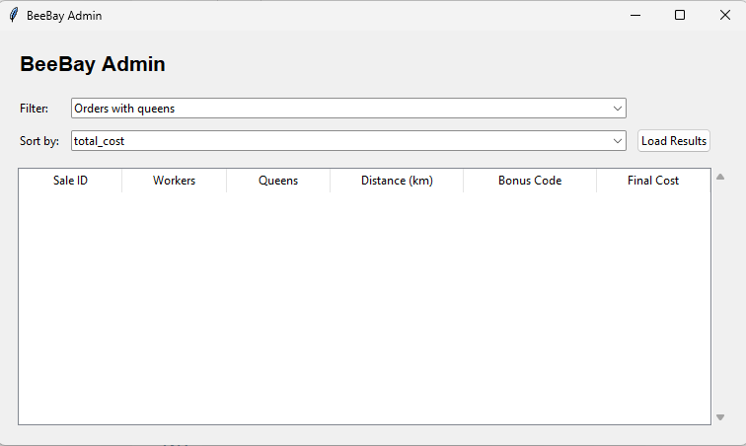

File format
You will be provided with a valid data file with some records already created.
The file now contains a sale_id.
sale_id,num_workers,num_queens,distance_km,bonus_code,final_cost
3,200,0,60,,22.00
4,50,2,15,FREEPOST,18.75

Pseudocode
BEGIN
{BeeBay Admin Search}

FILENAME ← "sales.csv"

INPUT filter_option
INPUT sort_option

results_list ← empty list

OPEN FILENAME FOR READING

READ and discard header row

FOR each record in the file

extract:
sale_id, num_workers, num_queens, distance_km,
bonus_code, final_cost

IF filter_option = "Orders with queens" THEN
IF num_queens > 0 THEN
add record to results_list
ENDIF
ELSE IF filter_option = "Orders with no queens" THEN
IF num_queens = 0 THEN
add record to results_list
ENDIF
ENDIF

ENDFOR

CLOSE FILENAME

{sorting step}
IF sort_option = "total_cost" THEN
sort results_list by final_cost
ELSE
sort results_list by distance_km
ENDIF

{display results}
FOR each record in results_list
display record in treeview
ENDFOR

END

Testing Table: Part 3
You must create a testing table that covers all pathways through the code
Item Tested | Test Data | Expected result | Actual Result | Changes Required

Module 4: Object Oriented Programming design
Your task in this module is to create a GUI using TKinter which allows the user to enter a new sales booking. There is limited new logic or processing here, you need to combine the elements from the other modules into a coherent app, using OOP design.
The module must meet the following requirements:
- Customers can order worker bees (currently at 5 cents each) and queen bees at $15

- Postage is calculated by using the distance from the warehouse as below:
  - Up to 50 kms - $10
  - Up to 150 kms - $20
  - 150 kms or more - $30

- BeeBay occasionally offers bonuses to customers. The software should cater for the following bonus codes:
  - SALE – 10% discount on final total (including the bees, the surcharge and the postage)
  - FREEPOST – free postage
  - HALFPOST – half-price postage.

- Any order that includes a queen bee adds a 12.5% surcharge to the order because of the extra difficulty in keeping queen bees alive in transit.

Once the save is complete, a confirmation message should be displayed.

Ensure you have:
- Sufficient meaningful internal documentation
- Validated inputs for existence, type and range
- Created a testing table to ensure all pathways through the code are covered

Design Notes
You will be given an application framework with many of the structural and visual elements and need to demonstrate your understanding of how these combine with the logical elements from previous modules.

App Structure
BeeOrderingApp
│
├── main.py
├── app.py
├── data/
│ └── yyyy-mm-ddsales.csv
├── models/
│ └── order.py
├── repos/
│ └── order_repo.py
└── screens/
└── orders_screen.py

Data file
You will need to save the order into a CSV file. The file should include the current date and “sales” in the file name. For example, “2026-16-03sales.csv”
The file should contain a header row with the field names.
Each sale should have a unique ID number

sale_id,num_workers,num_queens,distance_km,bonus_code,final_cost
4,50,2,15,FREEPOST,18.75

Object Descriptions
Name | Order
Properties/ Attributes | ID (integer)  num_workers (integer)  num_queens (integer)  distance_km (float)  bonus_code (string)  final_cost (float) | Unique integer  Number of worker bees ordered (0 or more)*  Number of queen bees ordered (0 or more)*  Distance (in kms) from warehouse for transport (>0)  One of SALE, FREEPOST or HALFPOST  Final cost for the order, 2 decimal places
Methods | __init__(*all attributes)  calculate()  to_csv_row() | Creates a new booking object  - Could be a list, a dictionary or individual elements  Calculate the cost of an order  Returns list of booking information is the correct order for storing

Name | BookingRepo
Properties/ Attributes | filename (string) | Path to the CSV file that stores all bookings
Methods | get_next_id()  check_queen_count(order)  save (order) | Determines the next available unique ID, or creates file  Ensure no more than 10 queens are ordered per day (ie per file)  Appends a new booking to the CSV file

Mock-up
